Auto Ticket Classification using Flow Designer

Project Description
This project automates IT ticket handling for a school using ServiceNow. Tickets are raised in a custom Incident Workflow table. When a ticket is created without a Category, a Flow Designer flow reads the Short Description, sets the Category and Subcategory (Wi-Fi to Network, Projector to Hardware, Forgot password to Access, Slow computer to Performance) and sends a confirmation email.

Scenarios
- Scenario 1: A teacher reports that the Wi-Fi is down. The flow sets Category = Network and Subcategory = Wi-Fi.
- Scenario 2: A teacher reports that the projector will not start. Category = Hardware, Subcategory = Projector.
- Scenario 3: A student forgot a password. Category = Access, Subcategory = Forgot password.
- Scenario 4: A lab computer is slow. Category = Performance, Subcategory = Slow computer.

Technical Architecture
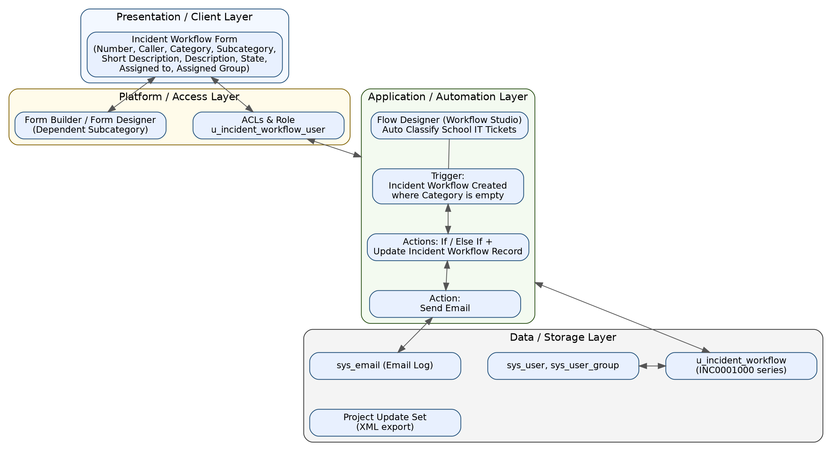
Figure 1: Technical architecture
Description: The form (presentation) saves data to the u_incident_workflow table. A Flow Designer flow reacts to the record creation, updates the record and sends an email. Configuration is packaged in an Update Set.

Pre-requisites
- ServiceNow Personal Developer Instance (developer.servicenow.com).
- Basic knowledge of tables, forms, choice lists and Flow Designer.
- Admin role to create tables and flows.

Project Workflow
Milestone 1: Update Set Setup
- Create the "Project Update Set" and make it the current set.
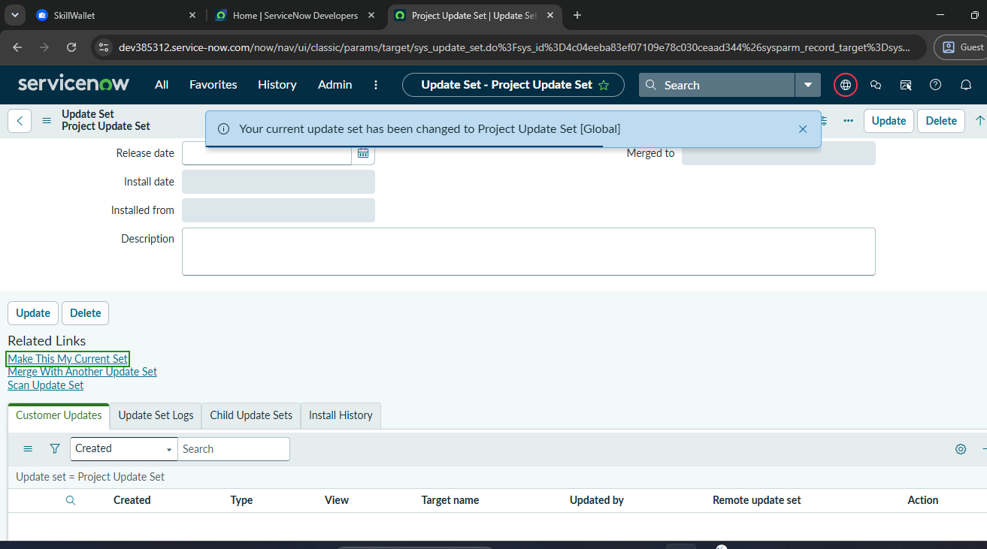
Update set made current
Milestone 2: Table, Fields and Choices
- Activity 2.1: Create the Incident Workflow table (label Incident Workflow, name u_incident_workflow). Controls: prefix INC, number 1000, 7 digits, create access controls with role u_incident_workflow_user.
- Activity 2.2: Add fields and configure the form: Caller, Category, Subcategory, Short Description, Description, State, Assigned to, Assigned Group.
- Activity 2.3: Add choices for Category (Network, Hardware, Access, Performance), Subcategory (Wi-Fi, Projector, Forgot password, Slow computer) and State (New, In progress, On hold, Resolved, Closed).
- Activity 2.4: Make Subcategory dependent on Category (dependent values network, hardware, access, performance).
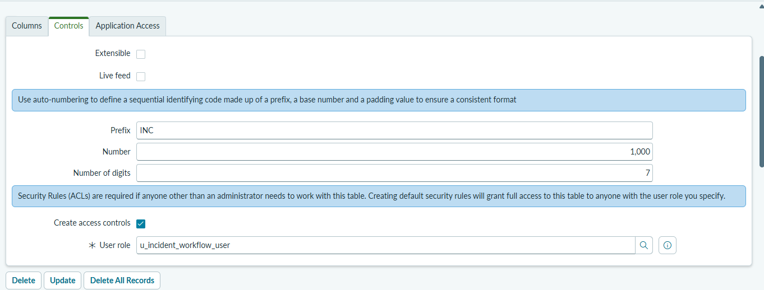
Table controls
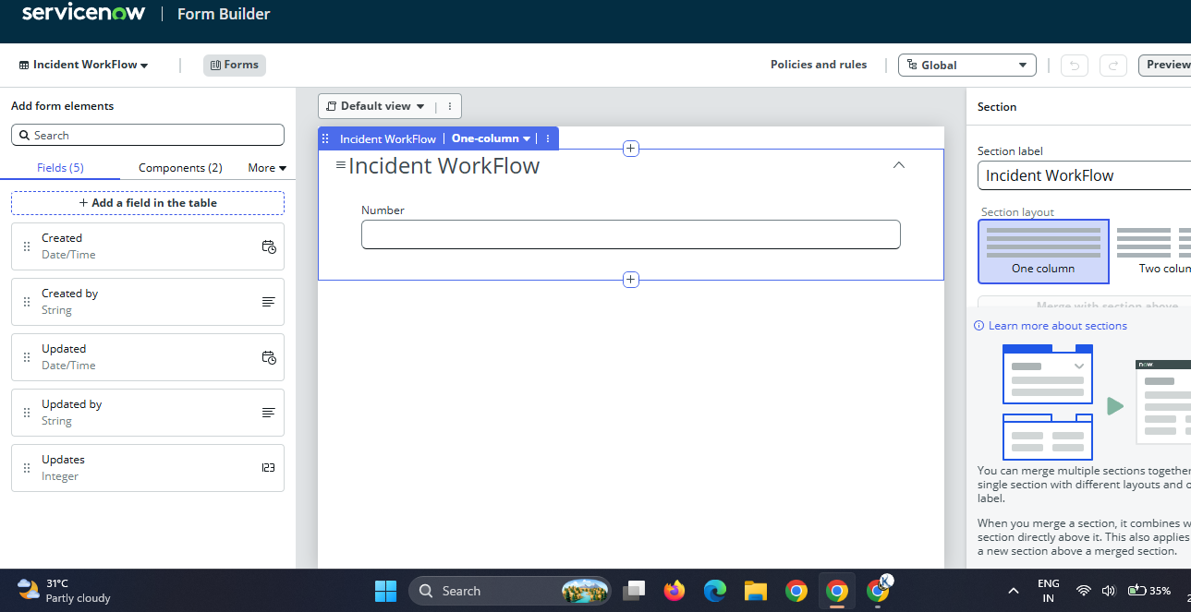
Form Builder
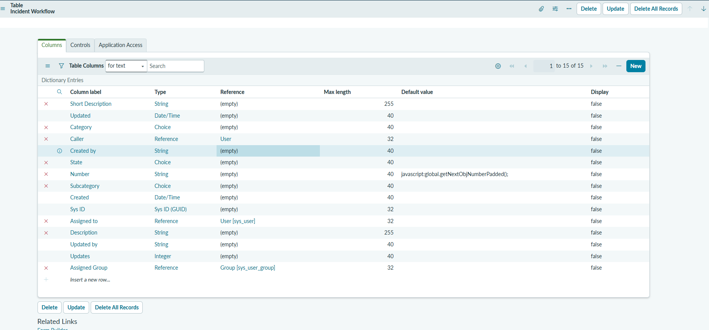
Table columns
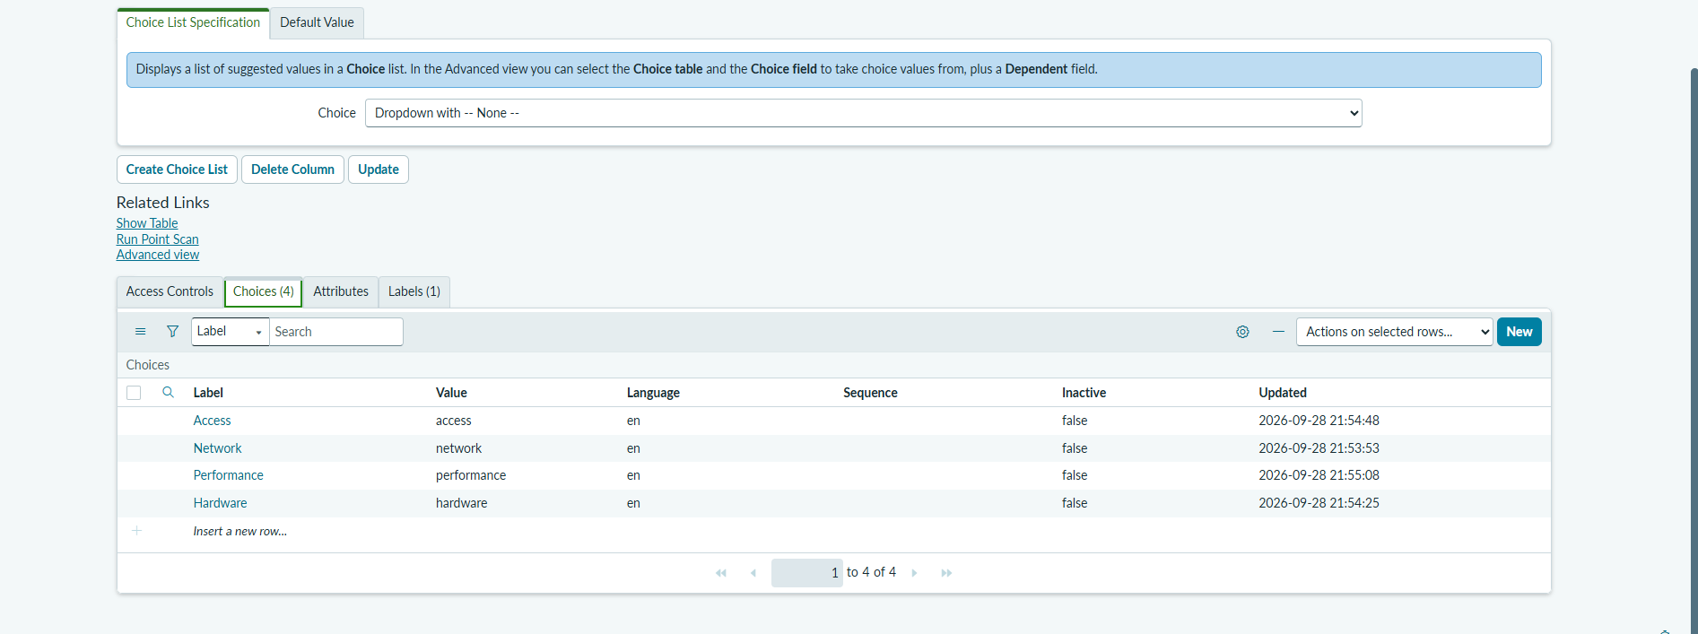
Category choices
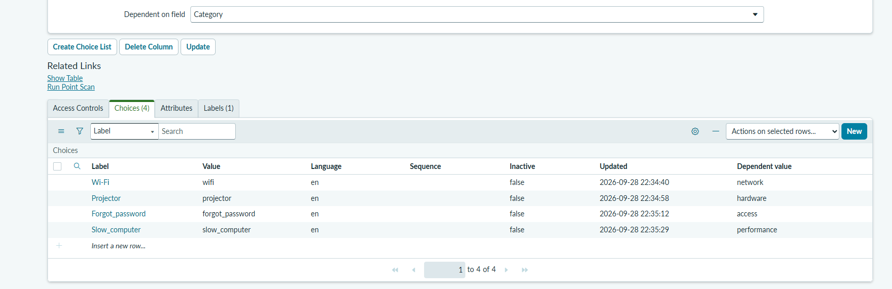
Subcategory dependent on Category
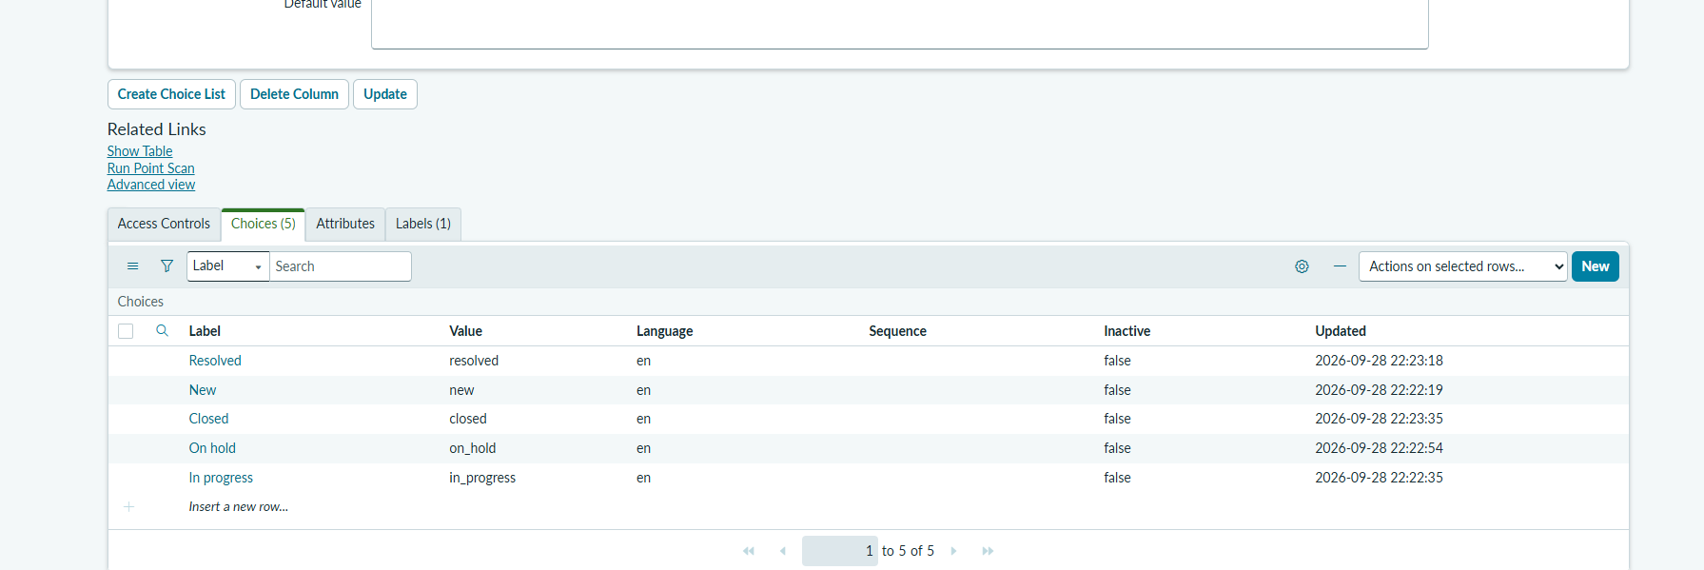
State choices
Milestone 3: Flow Designer
- Create the flow "Auto Classify School IT Tickets" in the Global scope.
- Trigger: Incident Workflow Created where Category is empty.
- Actions: If SD is Wi-Fi or Network, update the record; Else If Projector or Hardware; Else If Forgot password; Else If Performance (SD refers to the Short Description).
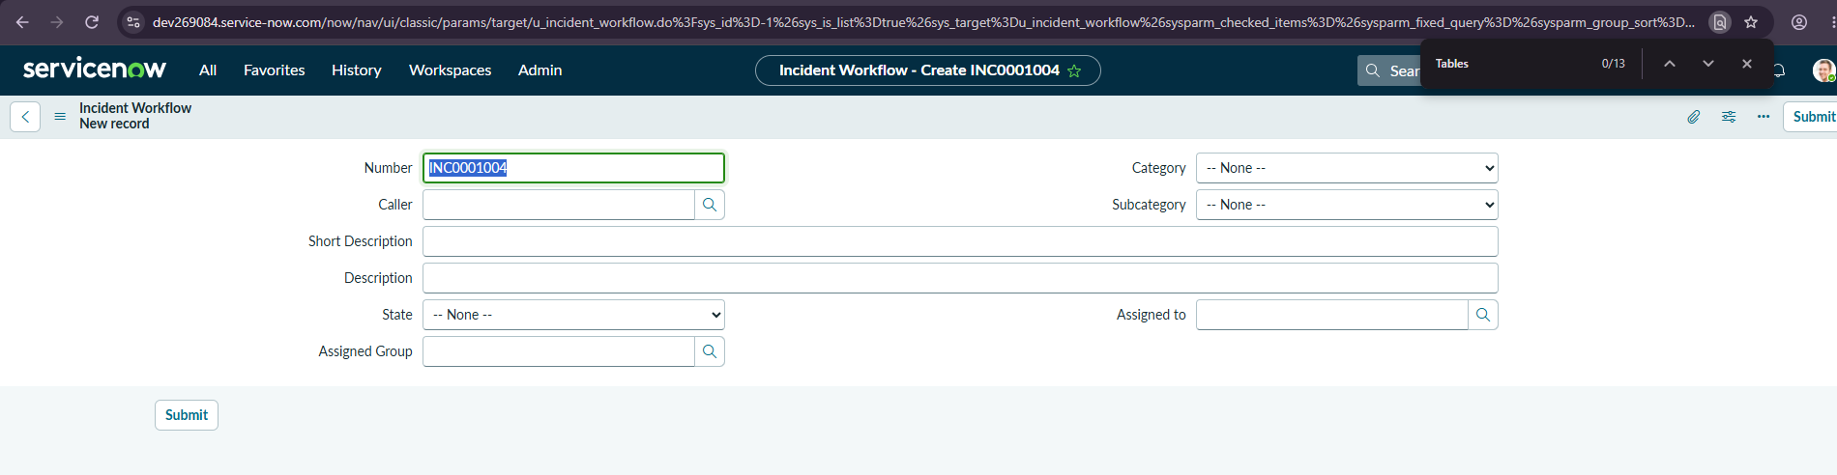
Incident Workflow new record form
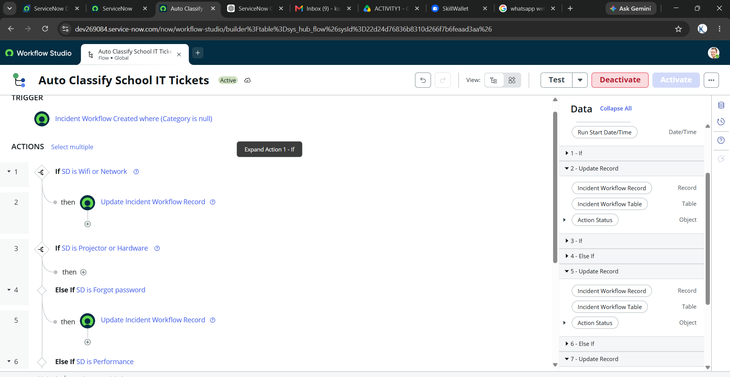
Flow trigger and actions
Milestone 4: Confirmation Email
- Add the Send Email action with subject "Your Request for the issue has been submitted." and body "Your IT ticket has been successfully submitted and classified. Thank you for contacting the IT Support team."
- Verify through Preview Email in the Email Log.
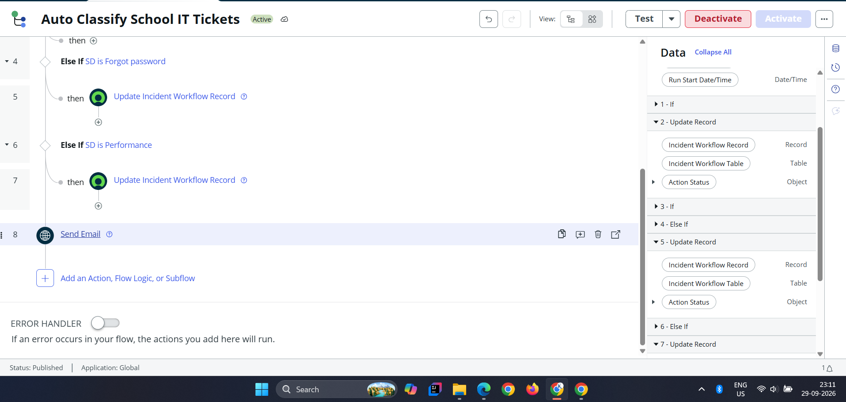
Send Email action
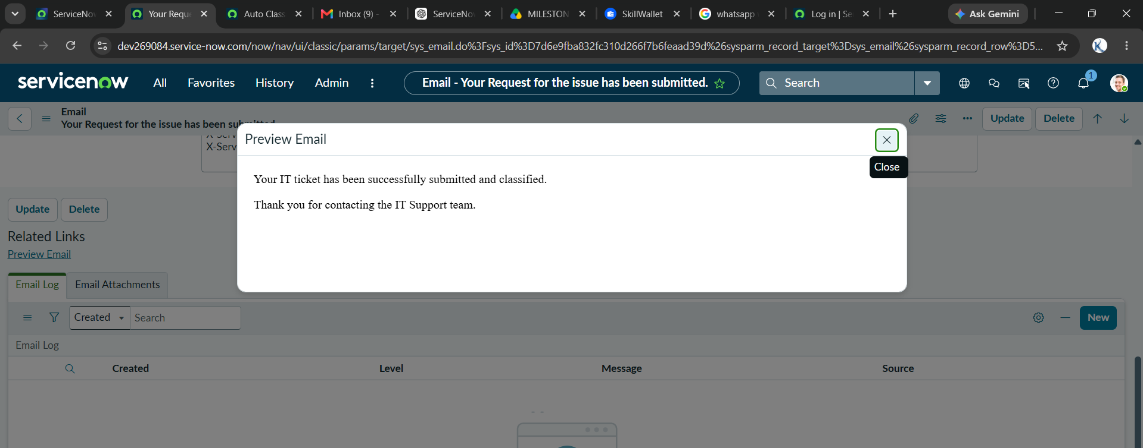
Email preview
Milestone 5: Update Set Export
- Mark the Project Update Set Complete and use Export to XML.
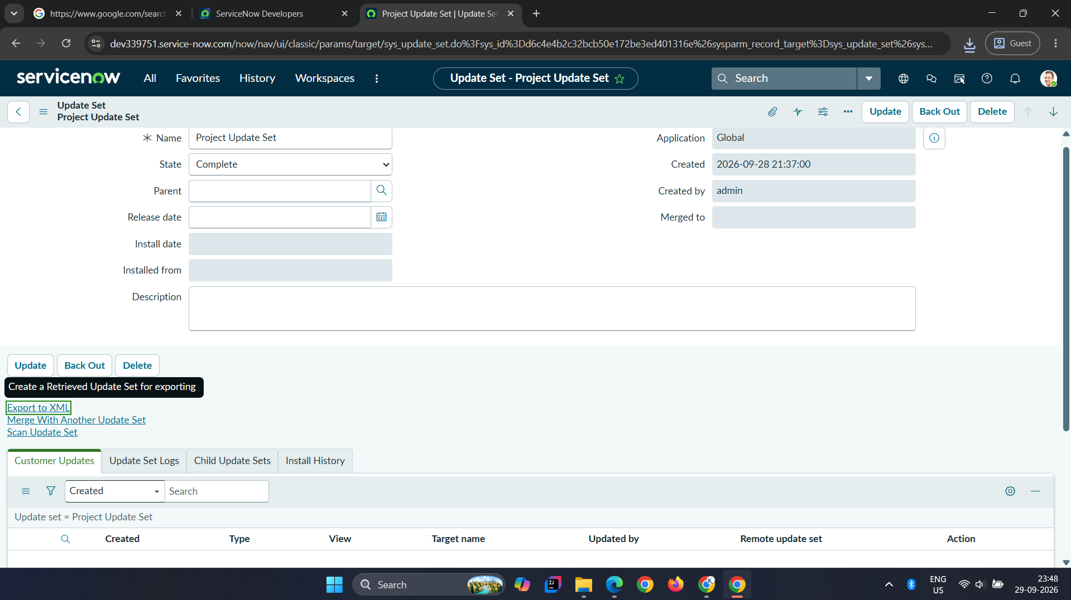
Update set export
Milestone 6: Conclusion
The project removes manual classification of school IT tickets and gives callers an instant confirmation. Future work includes assignment to groups, more issue types and dashboards.

